UNITED STATES
SECURITIES AND EXCHANGE COMMISSION
Washington, D.C. 20549

FORM 8-K

CURRENT REPORT
Pursuant to Section 13 or 15(d) of the Securities Exchange Act of 1934

Date of Report (Date of earliest event reported): June 3, 2026

TURN THERAPEUTICS INC.
(Exact name of registrant as specified in its charter)

Delaware |  | 001-42875 |  | 32-0456090
(State or other jurisdiction of  incorporation) |  | (Commission File Number) |  | (IRS Employer  Identification Number)

250 N. Westlake Blvd., Westlake Village, California |  | 91362
(Address of principal executive offices) |  | (Zip Code)

Registrant’s telephone number, including area code: (818) 564-4011

N/A
(Former name or former address, if changed since last report)

Check the appropriate box below if the Form 8-K filing is intended to simultaneously satisfy the filing obligation of the registrant under any of the following provisions:

☐ | Written communications pursuant to Rule 425 under the Securities Act (17 CFR 230.425)

☐ | Soliciting material pursuant to Rule 14a-12 under the Exchange Act (17 CFR 240.14a-12)

☐ | Pre-commencement communications pursuant to Rule 14d-2(b) under the Exchange Act (17 CFR 240.14d-2(b))

☐ | Pre-commencement communications pursuant to Rule 13e-4(c) under the Exchange Act (17 CFR 240.13e-4(c))

Securities registered pursuant to Section 12(b) of the Act:

Title of Each Class |  | Trading Symbol |  | Name of Each Exchange on Which Registered
Common Stock, par value $0.0001 per share |  | TTRX |  | The Nasdaq Stock Market LLC

Indicate by check mark whether the registrant is an emerging growth company as defined in Rule 405 of the Securities Act of 1933 (§230.405 of this chapter) or Rule 12b-2 of the Securities Exchange Act of 1934 (§240.12b-2 of this chapter).

Emerging growth company ☒

If an emerging growth company, indicate by check mark if the registrant has elected not to use the extended transition period for complying with any new or revised financial accounting standards provided pursuant to Section 13(a) of the Exchange Act. ☐

Item 7.01 Regulation FD Disclosure.

On June 1, 2026, Turn Therapeutics Inc. released an updated investor presentation (the “Investor Presentation”). A copy of the Investor Presentation is furnished as Exhibit 99.1 to this Current Report on Form 8-K.

The information in Item 7.01 of this Current Report on Form 8-K and the Investor Presentation furnished as Exhibit 99.1 hereto shall not be deemed “filed” for purposes of Section 18 of the Securities Exchange Act of 1934, as amended (the “Exchange Act”), or otherwise subject to the liabilities of that section, nor shall it be deemed incorporated by reference in any filing under the Securities Act of 1933, as amended, or the Exchange Act, except as expressly set forth by specific reference in such a filing.

Item 9.01 Financial Statements and Exhibits.

(d) Exhibits

Exhibit No. |  | Description
99.1 |  | Investor Presentation, dated June 3, 2026
104 |  | Cover Page Interactive Data File (embedded within the Inline XBRL document)

1

SIGNATURES

Pursuant to the requirements of the Securities Exchange Act of 1934, the registrant has duly caused this report to be signed on its behalf by the undersigned hereunto duly authorized.

 | TURN THERAPEUTICS INC.
Date: June 3, 2026
 | By: | /s/ Bradley Burnam
 | Name: | Bradley Burnam
 | Title: | Chief Executive Officer

2

Exhibit 99.1


2026 Jefferies Global Healthcare Conference June 2026

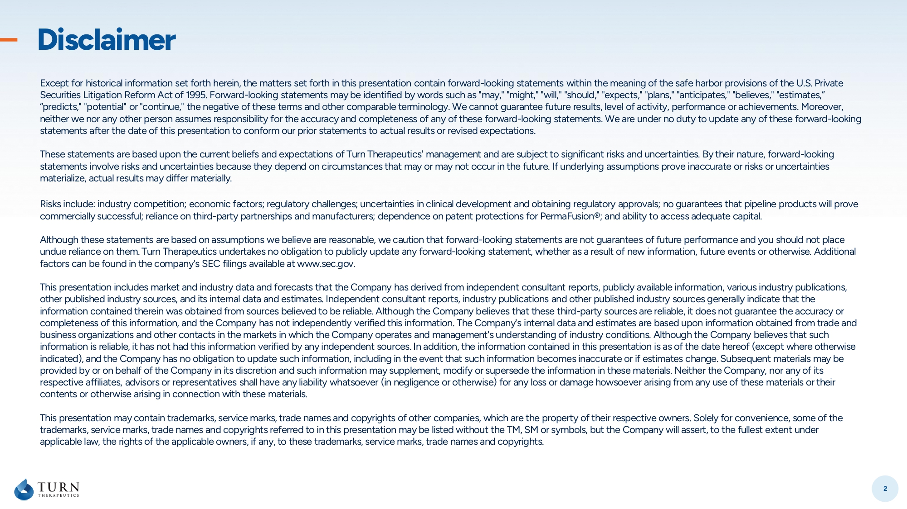
2 Disclaimer Except for historical information set forth herein, the matters set forth in this presentation contain forward - looking statement s within the meaning of the safe harbor provisions of the U.S. Private Securities Litigation Reform Act of 1995. Forward - looking statements may be identified by words such as "may," "might," "will," "should," "expects," "plans," "anticipates," "believes," "estimates,” “predicts," "potential" or "continue," the negative of these terms and other comparable terminology. We cannot guarantee futu re results, level of activity, performance or achievements. Moreover, neither we nor any other person assumes responsibility for the accuracy and completeness of any of these forward - looking stateme nts. We are under no duty to update any of these forward - looking statements after the date of this presentation to conform our prior statements to actual results or revised expectations. These statements are based upon the current beliefs and expectations of Turn Therapeutics' management and are subject to sign ifi cant risks and uncertainties. By their nature, forward - looking statements involve risks and uncertainties because they depend on circumstances that may or may not occur in the future. If u nde rlying assumptions prove inaccurate or risks or uncertainties materialize, actual results may differ materially. Risks include: industry competition; economic factors; regulatory challenges; uncertainties in clinical development and obtai nin g regulatory approvals; no guarantees that pipeline products will prove commercially successful; reliance on third - party partnerships and manufacturers; dependence on patent protections for PermaFusion ®; and ability to access adequate capital. Although these statements are based on assumptions we believe are reasonable, we caution that forward - looking statements are not guarantees of future performance and you should not place undue reliance on them. Turn Therapeutics undertakes no obligation to publicly update any forward - looking statement, whether as a result of new information, future events or otherwise. Additional factors can be found in the company's SEC filings available at www.sec.gov. This presentation includes market and industry data and forecasts that the Company has derived from independent consultant re por ts, publicly available information, various industry publications, other published industry sources, and its internal data and estimates. Independent consultant reports, industry publications and other published industry sources generally indicate that the information contained therein was obtained from sources believed to be reliable. Although the Company believes that these thi rd - party sources are reliable, it does not guarantee the accuracy or completeness of this information, and the Company has not independently verified this information. The Company's internal dat a a nd estimates are based upon information obtained from trade and business organizations and other contacts in the markets in which the Company operates and management's understanding of indu str y conditions. Although the Company believes that such information is reliable, it has not had this information verified by any independent sources. In addition, the information co nta ined in this presentation is as of the date hereof (except where otherwise indicated), and the Company has no obligation to update such information, including in the event that such information become s i naccurate or if estimates change. Subsequent materials may be provided by or on behalf of the Company in its discretion and such information may supplement, modify or supersede the inform ati on in these materials. Neither the Company, nor any of its respective affiliates, advisors or representatives shall have any liability whatsoever (in negligence or otherwise) for any l oss or damage howsoever arising from any use of these materials or their contents or otherwise arising in connection with these materials. This presentation may contain trademarks, service marks, trade names and copyrights of other companies, which are the propert y o f their respective owners. Solely for convenience, some of the trademarks, service marks, trade names and copyrights referred to in this presentation may be listed without the TM, SM or sy mbo ls, but the Company will assert, to the fullest extent under applicable law, the rights of the applicable owners, if any, to these trademarks, service marks, trade names and copyrights.

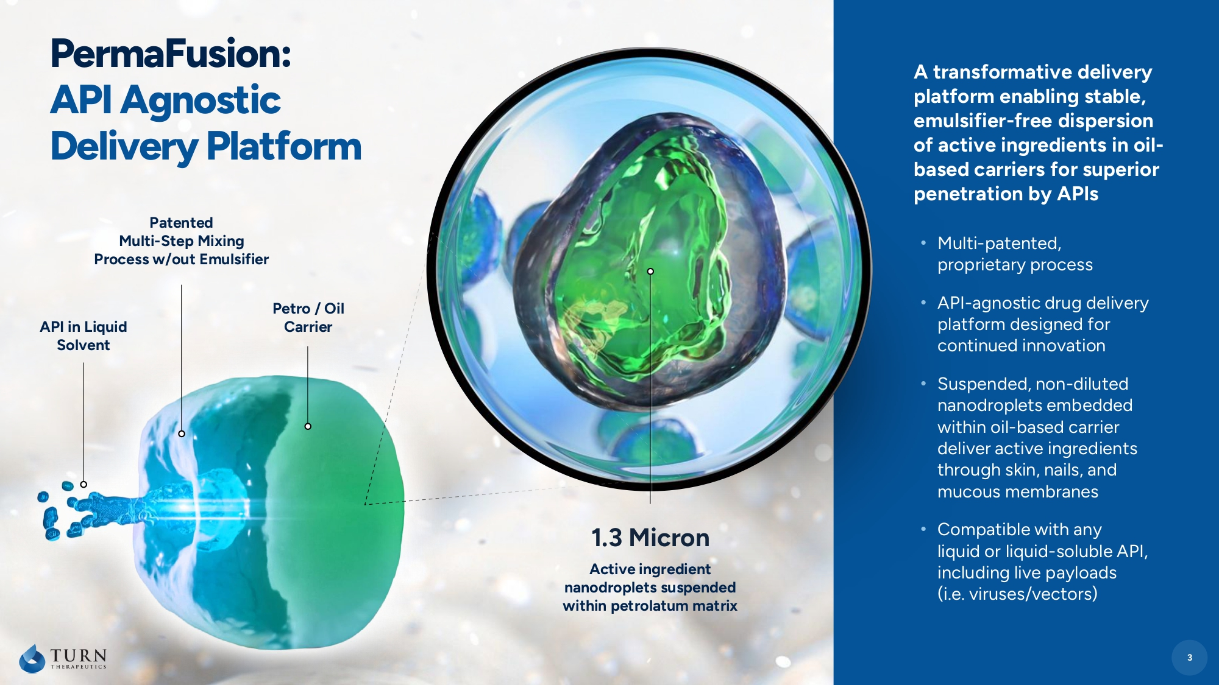
3 API in Liquid Solvent Patented Multi - Step Mixing Process w/out Emulsifier Petro / Oil Carrier A transformative delivery platform enabling stable, emulsifier - free dispersion of active ingredients in oil - based carriers for superior penetration by APIs • Multi - patented, proprietary process • API - agnostic drug delivery platform designed for continued innovation • Suspended, non - diluted nanodroplets embedded within oil - based carrier deliver active ingredients through skin, nails, and mucous membranes • Compatible with any liquid or liquid - soluble API, including live payloads (i .e. viruses/vectors) PermaFusion : API Agnostic Delivery Platform 3 1.3 Micron Active ingredient nanodroplets suspended within petrolatum matrix

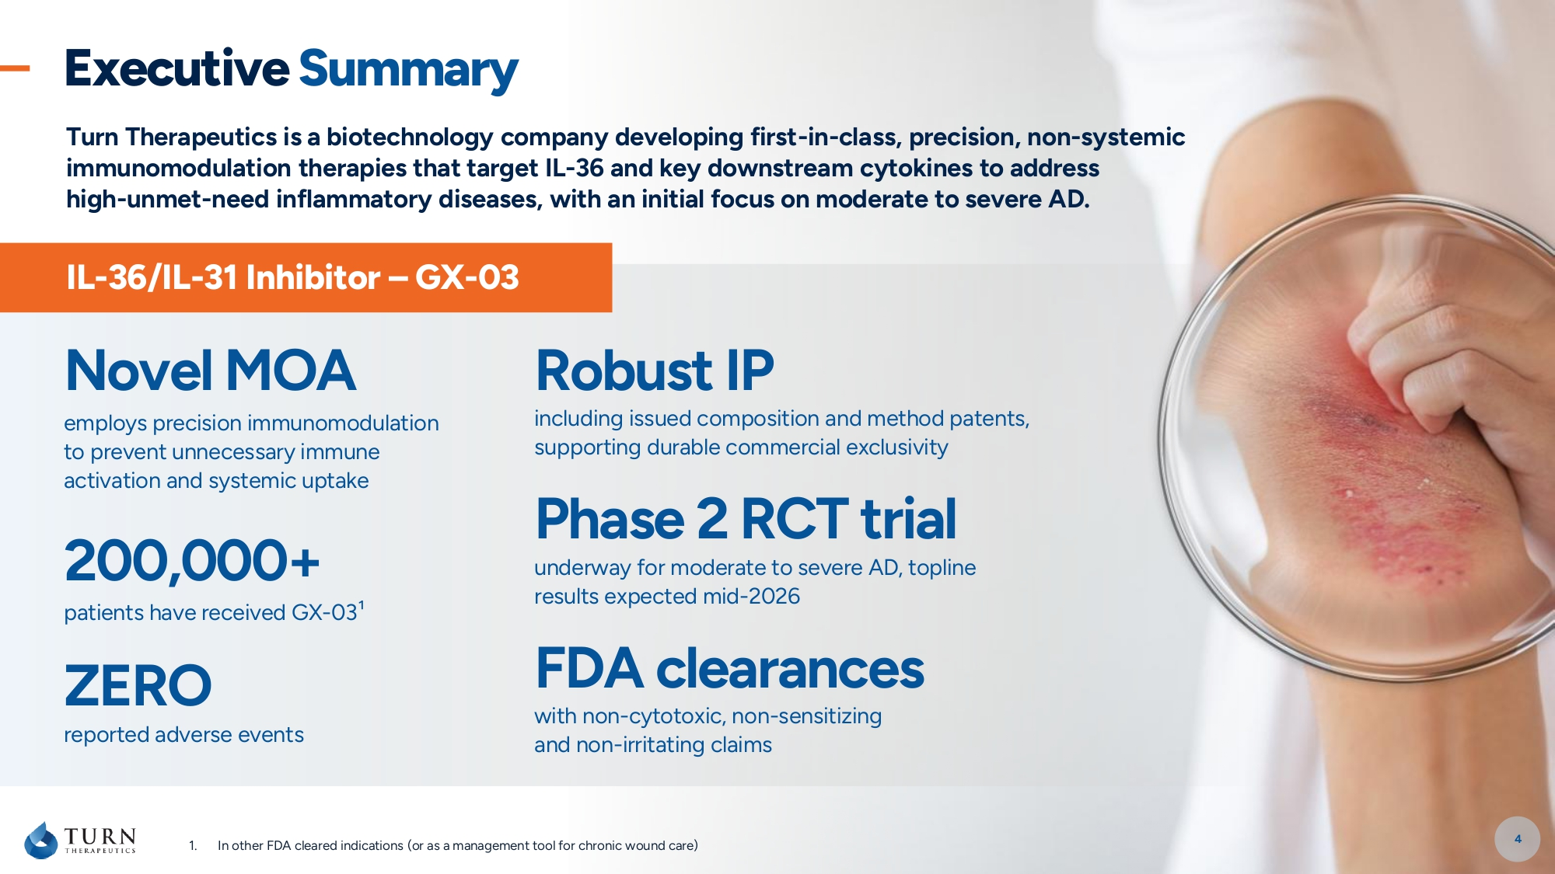
Turn Therapeutics is a biotechnology company developing first - in - class, precision, non - systemic immunomodulation therapies that target IL - 36 and key downstream cytokines to address high - unmet - need inflammatory diseases, with an initial focus on moderate to severe AD. 1. In other FDA cleared indications (or as a management tool for chronic wound care) IL - 36/IL - 31 Inhibitor – GX - 03 Robust IP including issued composition and method patents, supporting durable commercial exclusivity Novel MOA employs precision immunomodulation to prevent unnecessary immune activation and systemic uptake Executive Summary 4 ZERO reported adverse events 200,000+ patients have received GX - 03 ¹ FDA clearances with non - cytotoxic, non - sensitizing and non - irritating claims Phas e 2 RCT trial underway for moderate to severe AD, topline results expected mid - 2026

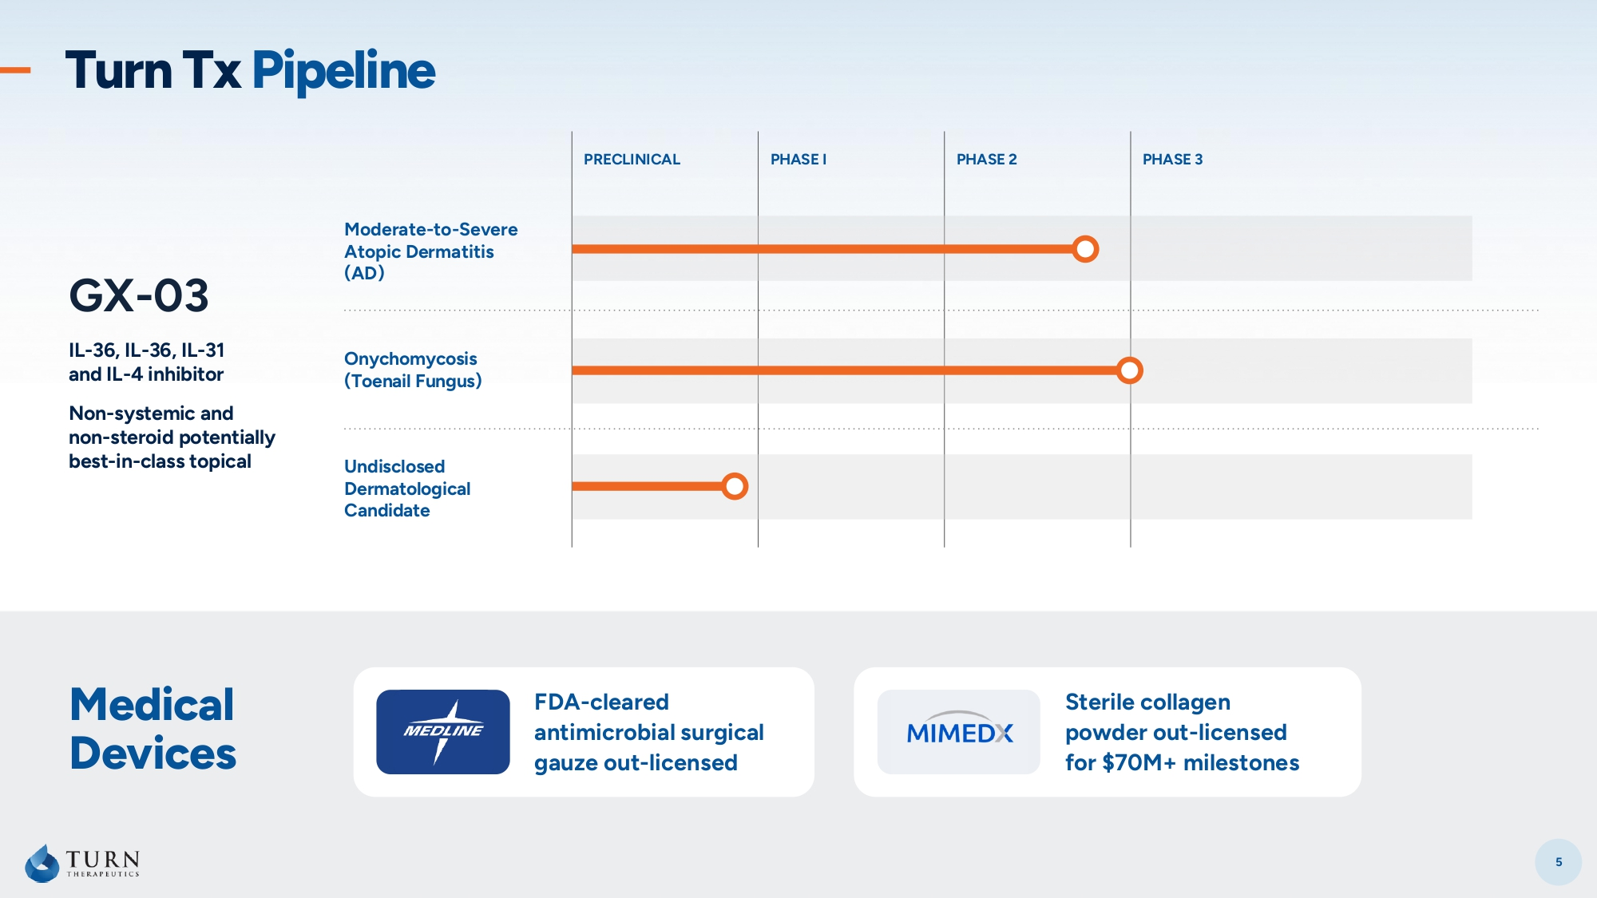
5 Medical Devices FDA - cleared antimicrobial surgical gauze out - licensed Sterile collagen powder out - licensed for $70M+ milestones Turn Tx Pipeline PHASE 3 PHASE 2 PHASE I PRECLINICAL Moderate - to - Severe Atopic Dermatitis (AD) GX - 03 IL - 36, IL - 36, IL - 31 and IL - 4 inhibitor Non - systemic and non - steroid potentially best - in - class topical Onychomycosis (Toenail Fungus) Undisclosed Dermatological Candidate

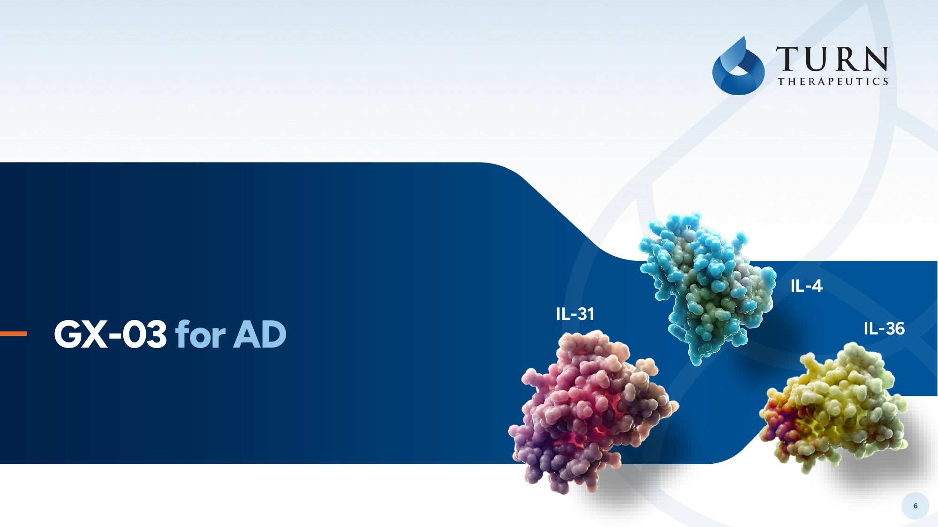
6 GX - 03 for AD IL - 31 IL - 4 IL - 36

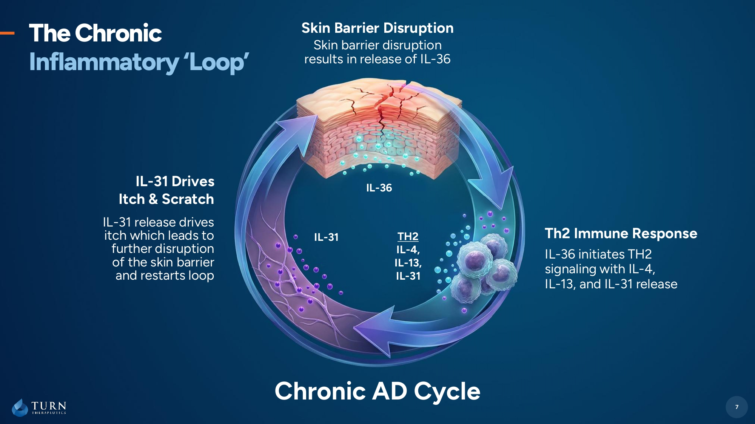
7 The Chronic Inflammatory ‘Loop’ TH2 IL - 4, IL - 13, IL - 31 IL - 31 Chronic AD Cycle IL - 31 Drives Itch & Scratch Skin Barrier Disruption Skin barrier disruption results in release of IL - 36 IL - 36 initiates TH2 signaling with IL - 4, IL - 13, and IL - 31 release IL - 31 release drives itch which leads to further disruption of the skin barrier and restarts loop 7 IL - 36 Th2 Immune Response

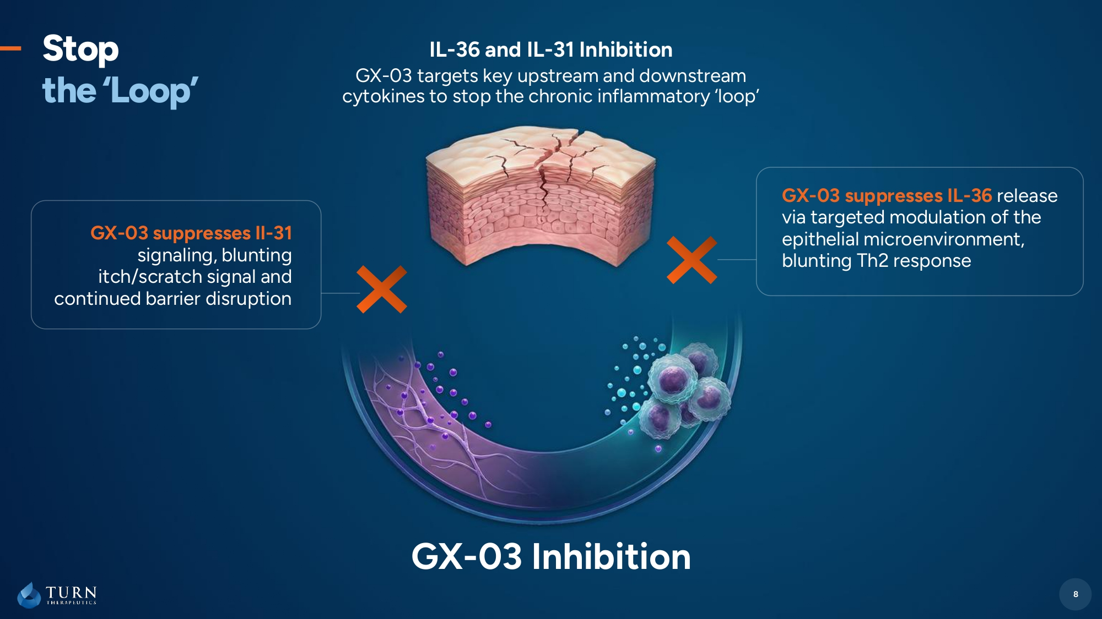
8 Stop the ‘Loop’ GX - 03 Inhibition 8 GX - 03 suppresses IL - 36 release via targeted modulation of the epithelial microenvironment, blunting Th2 response GX - 03 suppresses Il - 31 signaling, blunting itch/scratch signal and continued barrier disruption IL - 36 and IL - 31 Inhibition GX - 03 targets key upstream and downstream cytokines to stop the chronic inflammatory ‘loop’

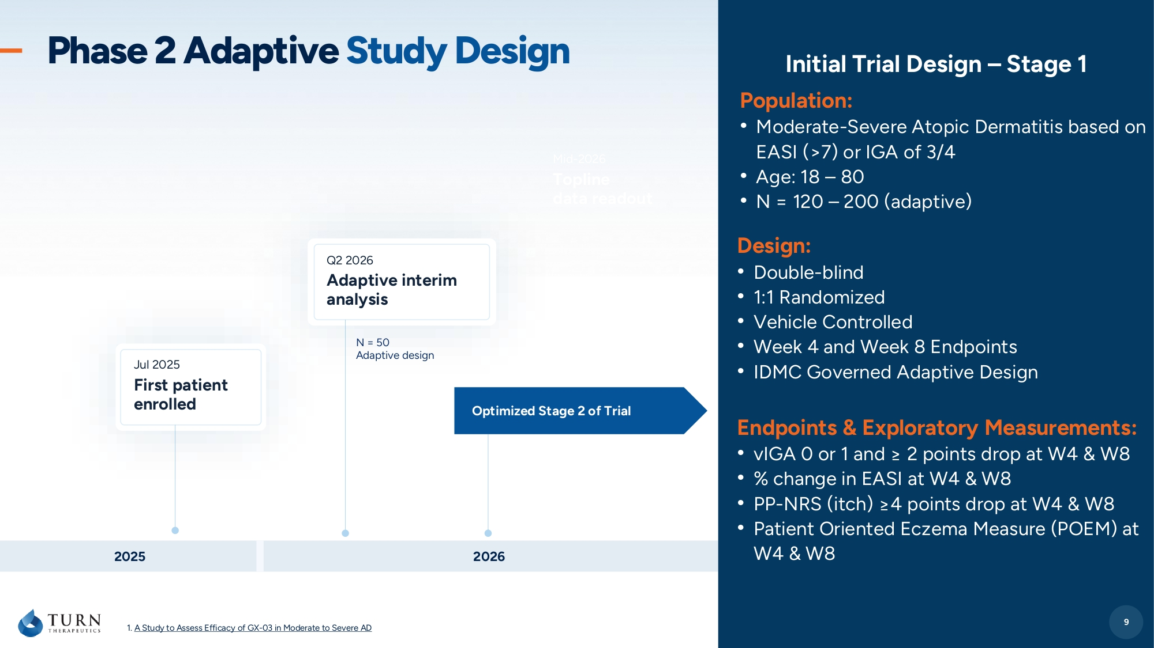
9 Phase 2 Adaptive Study Design Design: • Double - blind • 1:1 Randomized • Vehicle Controlled • Week 4 and Week 8 Endpoints • IDMC Governed Adaptive Design 9 Initial Trial Design – Stage 1 Endpoints & Exploratory Measurements: • vIGA 0 or 1 and ≥ 2 points drop at W4 & W8 • % change in EASI at W4 & W8 • PP - NRS (itch) ≥4 points drop at W4 & W8 • Patient Oriented Eczema Measure (POEM) at W4 & W8 Population: • Moderate - Severe Atopic Dermatitis based on EASI (>7) or IGA of 3/4 • Age: 18 – 80 • N = 120 – 200 (adaptive) 1. A Study to Assess Efficacy of GX - 03 in Moderate to Severe AD 2026 2025 Jul 2025 First patient enrolled Q2 2026 Adaptive interim analysis Mid - 2026 Topline data readout N = 50 Adaptive design Optimized Stage 2 of Trial

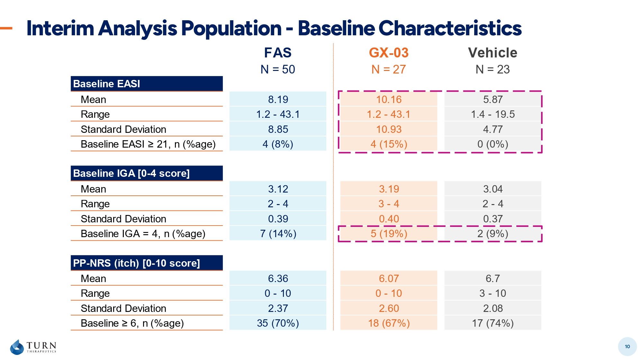
FAS GX-03 Vehicle N = 50 N = 27 N = 23 Baseline EASI Mean 8.19 10.16 5.87 Range 1.2 - 43.1 1.2 - 43.1 1.4 - 19.5 Standard Deviation 8.85 10.93 4.77 Baseline EASI ≥ 21, n (%age) 4 (8%) 4 (15%) 0 (0%) Baseline IGA [0-4 score] Mean 3.12 3.19 3.04 Range 2 - 4 3 - 4 2 - 4 Standard Deviation 0.39 0.40 0.37 Baseline IGA = 4, n (%age) 7 (14%) 5 (19%) 2 (9%) PP-NRS (itch) [0-10 score] Mean 6.36 6.07 6.7 Range 0 - 10 0 - 10 3 - 10 Standard Deviation 2.37 2.60 2.08 Baseline ≥ 6, n (%age) 35 (70%) 18 (67%) 17 (74%) Interim Analysis Population - Baseline Characteristics 10

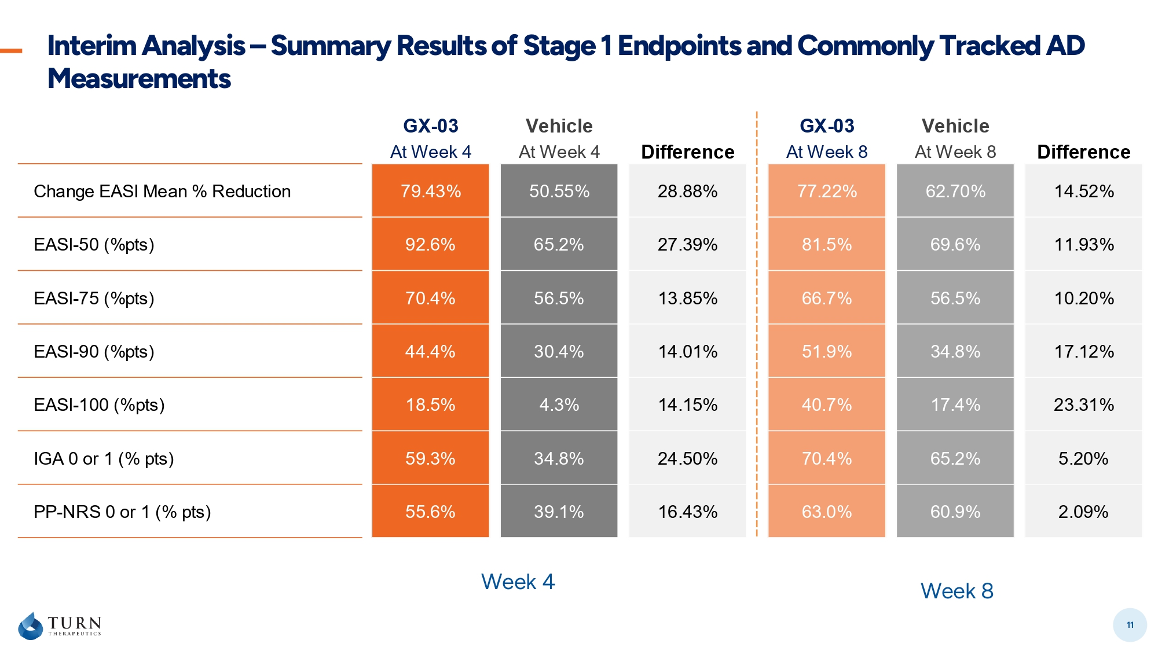
Interim Analysis – Summary Results of Stage 1 Endpoints and Commonly Tracked AD Measurements 11 GX-03 Vehicle GX-03 Vehicle At Week 4 At Week 4 Difference At Week 8 At Week 8 Difference Change EASI Mean % Reduction 79.43% 50.55% 28.88% 77.22% 62.70% 14.52% EASI-50 (%pts) 92.6% 65.2% 27.39% 81.5% 69.6% 11.93% EASI-75 (%pts) 70.4% 56.5% 13.85% 66.7% 56.5% 10.20% EASI-90 (%pts) 44.4% 30.4% 14.01% 51.9% 34.8% 17.12% EASI-100 (%pts) 18.5% 4.3% 14.15% 40.7% 17.4% 23.31% IGA 0 or 1 (% pts) 59.3% 34.8% 24.50% 70.4% 65.2% 5.20% PP-NRS 0 or 1 (% pts) 55.6% 39.1% 16.43% 63.0% 60.9% 2.09% Week 4 Week 8

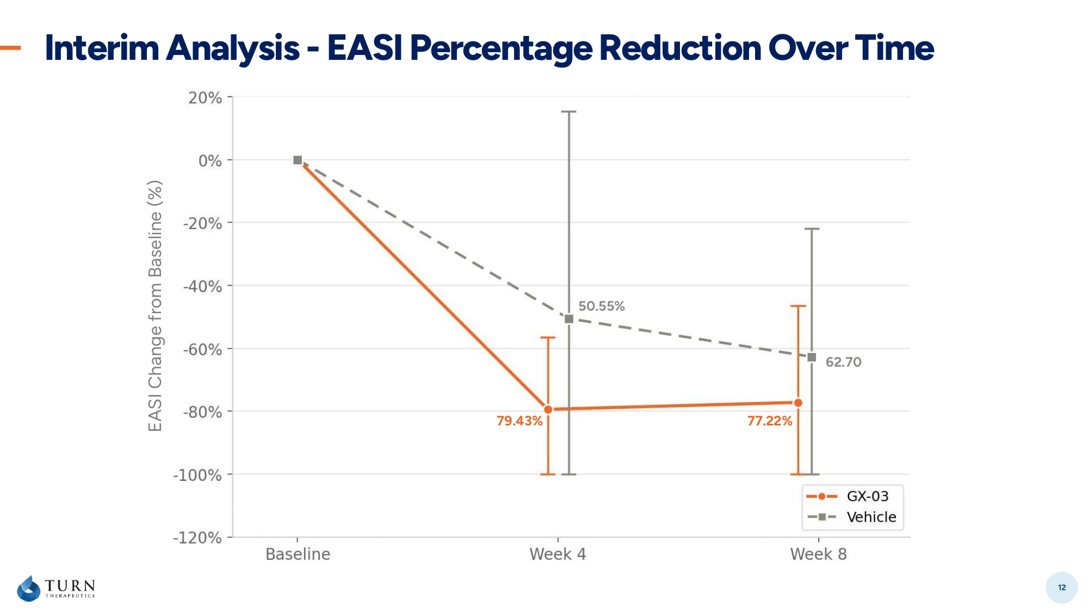
Interim Analysis - EASI Percentage Reduction Over Time 12 EASI Change from Baseline (%) 79.43% 77.22% 50.55% 62.70

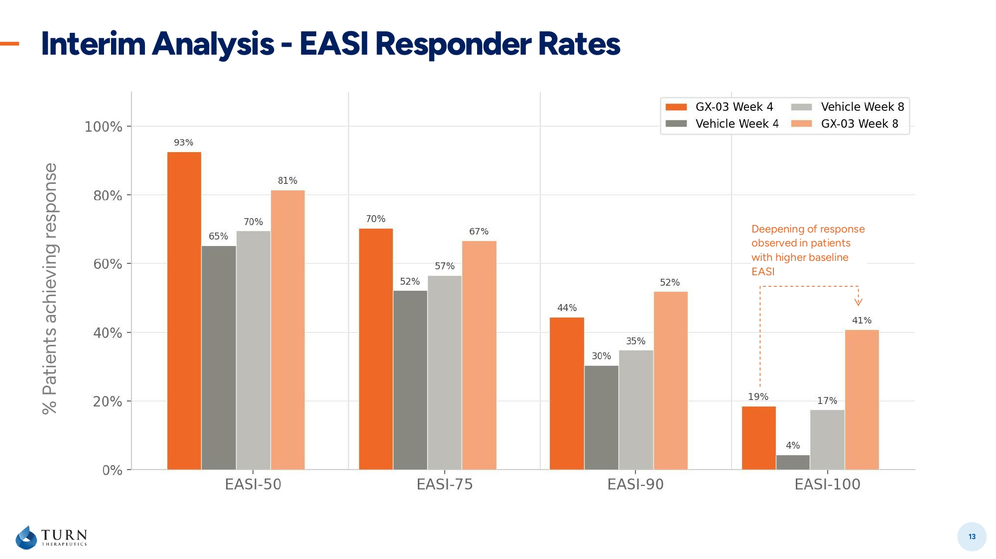
Interim Analysis - EASI Responder Rates 13 % P atients achieving response Deepening of response observed in patients with higher baseline EASI

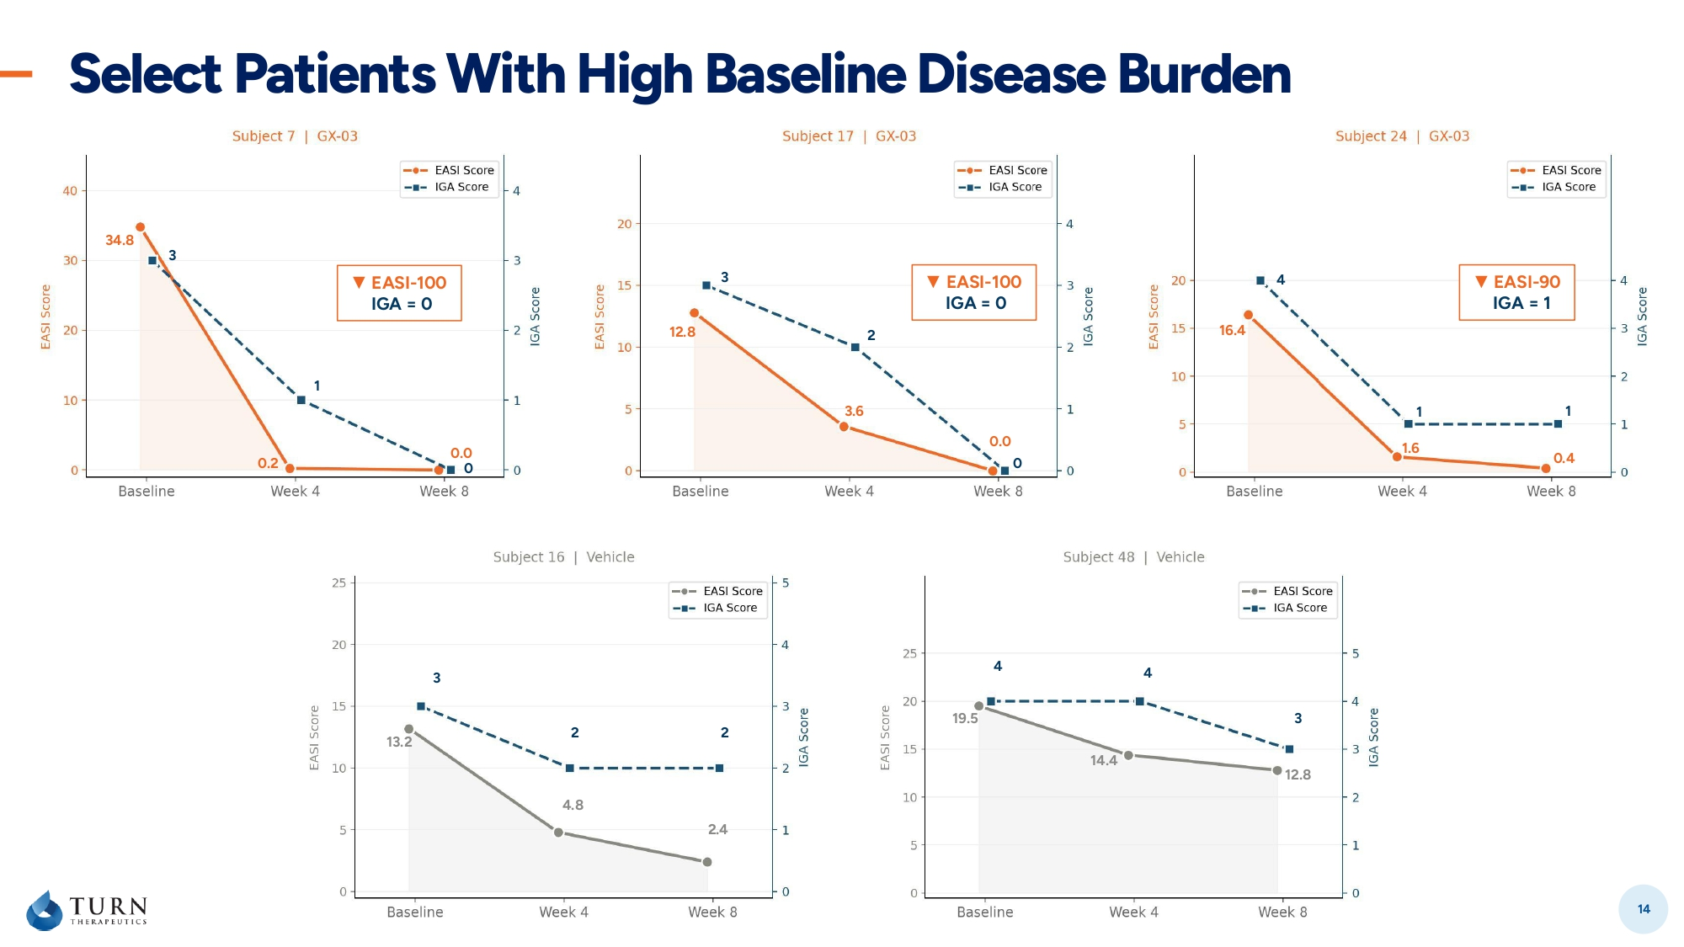
Select Patients With High Baseline Disease Burden 14 34.8 0.2 0.0 3 1 0 ▼ EASI - 100 IGA = 0 12.8 3.6 0.0 3 2 0 ▼ EASI - 100 IGA = 0 16.4 1.6 0.4 4 1 1 ▼ EASI - 90 IGA = 1 3 2 2 13.2 4.8 2.4 4 4 3 19.5 14.4 12.8

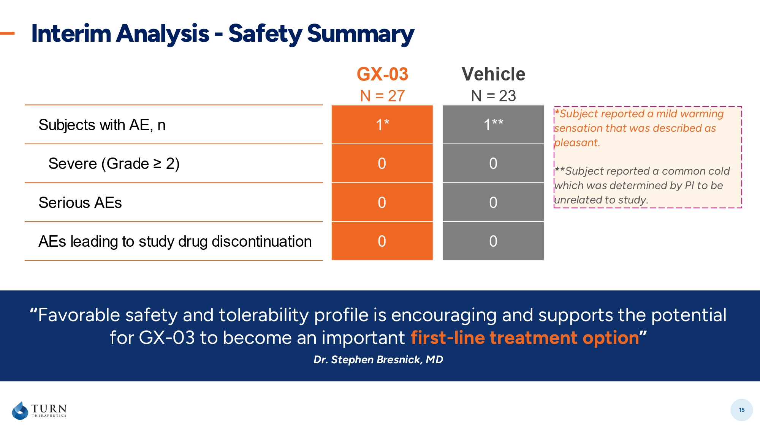
Interim Analysis - Safety Summary 15 * Subject reported a mild warming sensation that was described as pleasant. ** Subject reported a common cold which was determined by PI to be unrelated to study. “ Favorable safety and tolerability profile is encouraging and supports the potential for GX - 03 to become an important first - line treatment option ” Dr. Stephen Bresnick, MD GX-03 Vehicle N = 27 N = 23 Subjects with AE, n 1* 1** Severe (Grade ≥ 2) 0 0 Serious AEs 0 0 AEs leading to study drug discontinuation 0 0

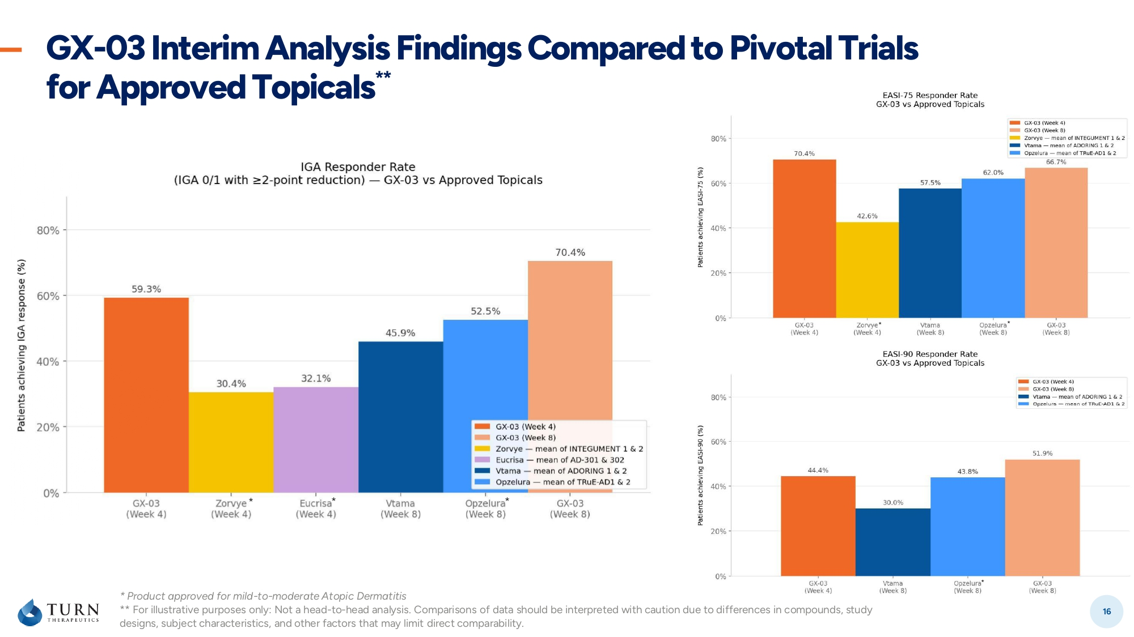
GX - 03 Interim Analysis Findings Compared to Pivotal Trials for Approved Topicals ** 16 * * * * * * * Product approved for mild - to - moderate Atopic Dermatitis ** For illustrative purposes only: Not a head - to - head analysis. Comparisons of data should be interpreted with caution due to di fferences in compounds, study designs, subject characteristics, and other factors that may limit direct comparability.

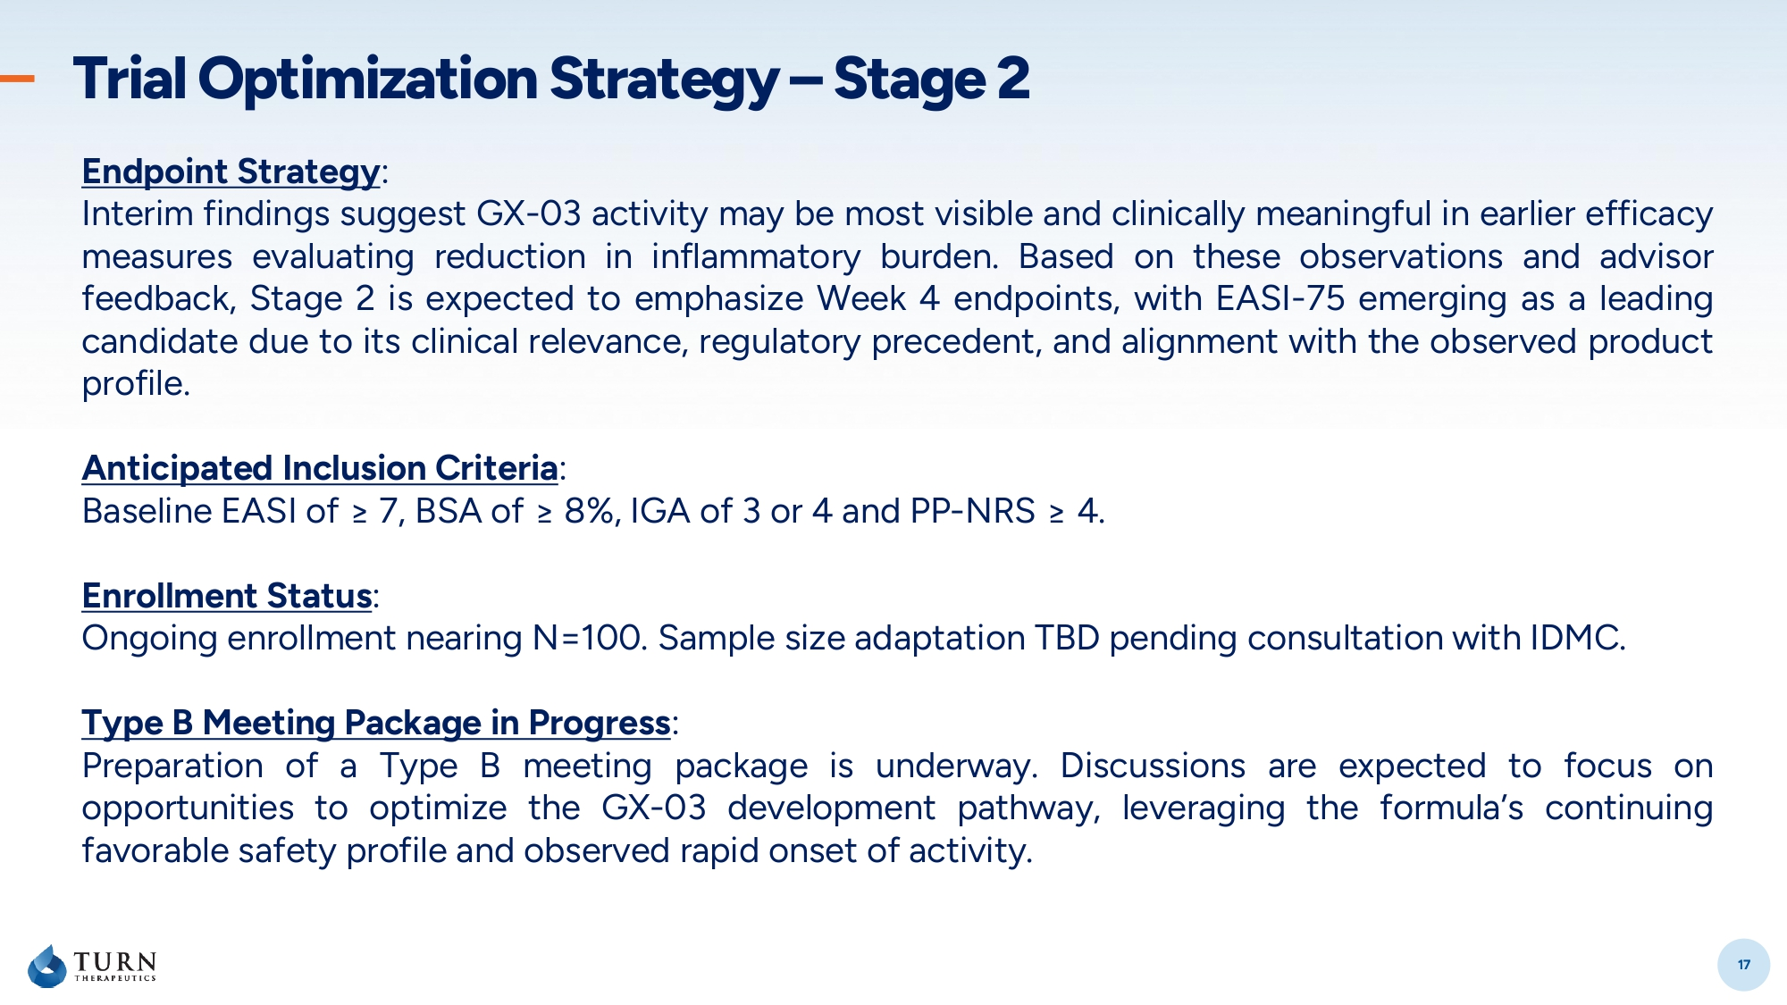
17 Trial Optimization Strategy – Stage 2 17 Endpoint Strategy : Interim findings suggest GX - 03 activity may be most visible and clinically meaningful in earlier efficacy measures evaluating reduction in inflammatory burden . Based on these observations and advisor feedback, Stage 2 is expected to emphasize Week 4 endpoints, with EASI - 75 emerging as a leading candidate due to its clinical relevance, regulatory precedent, and alignment with the observed product profile . Anticipated Inclusion Criteria : Baseline EASI of ≥ 7 , BSA of ≥ 8 % , IGA of 3 or 4 and PP - NRS ≥ 4 . Enrollment Status : Ongoing enrollment nearing N= 100 . Sample size adaptation TBD pending consultation with IDMC . Type B Meeting Package in Progress : Preparation of a Type B meeting package is underway . Discussions are expected to focus on opportunities to optimize the GX - 03 development pathway, leveraging the formula’s continuing favorable safety profile and observed rapid onset of activity .

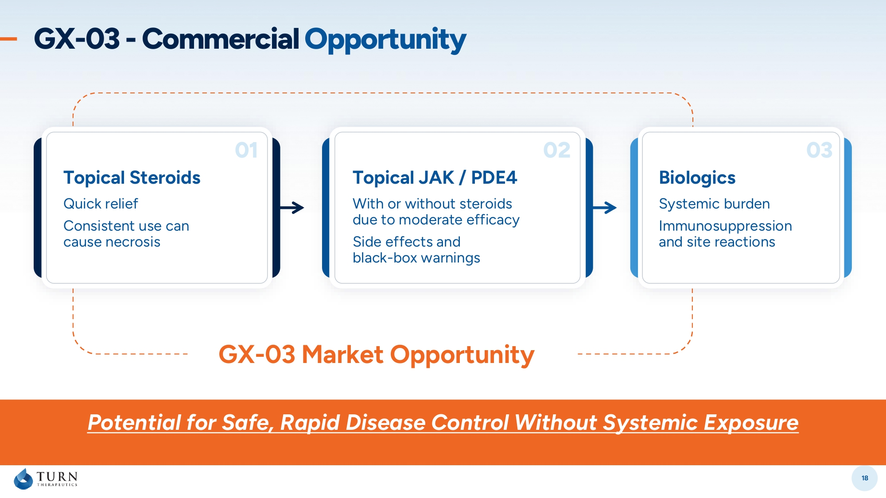
18 GX - 03 Market Opportunity GX - 03 - Commercial Opportunity 02 03 Topical JAK / PDE4 With or without steroids due to moderate efficacy Side effects and black - box warnings Biologics Systemic burden Immunosuppression and site reactions 01 Topical Steroids Quick relief Consistent use can cause necrosis Potential for Safe, Rapid Disease Control Without Systemic Exposure

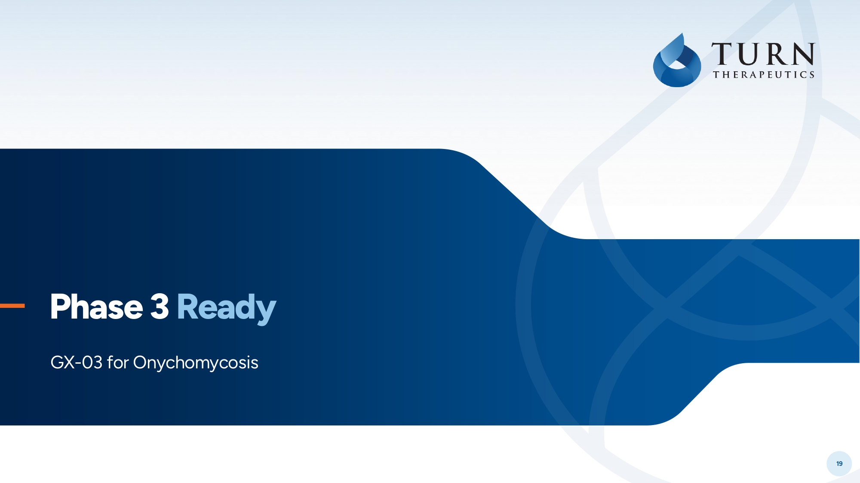
19 (Toenail Fungus) Phase 3 Ready GX - 03 for Onychomycosis

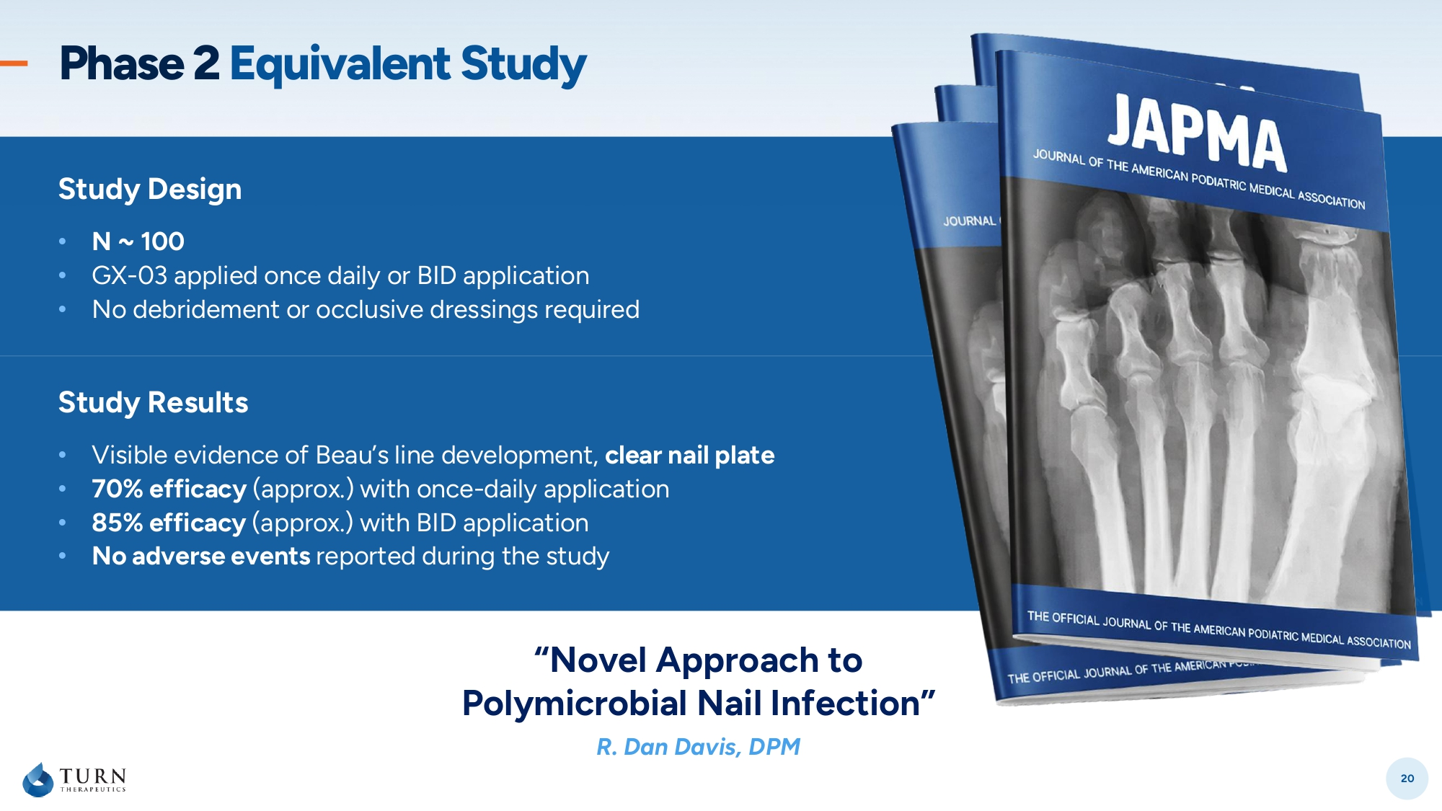
20 Study Results • Visible evidence of Beau’s line development, clear nail plate • 70% efficacy (approx .) with once - daily application • 85% efficacy (approx .) with BID application • No adverse events reported during the study Study Design • N ~ 100 • GX - 03 applied once daily or BID application • No debridement or occlusive dressings required Phase 2 Equivalent Study “Novel Approach to Polymicrobial Nail Infection” R. Dan Davis, DPM

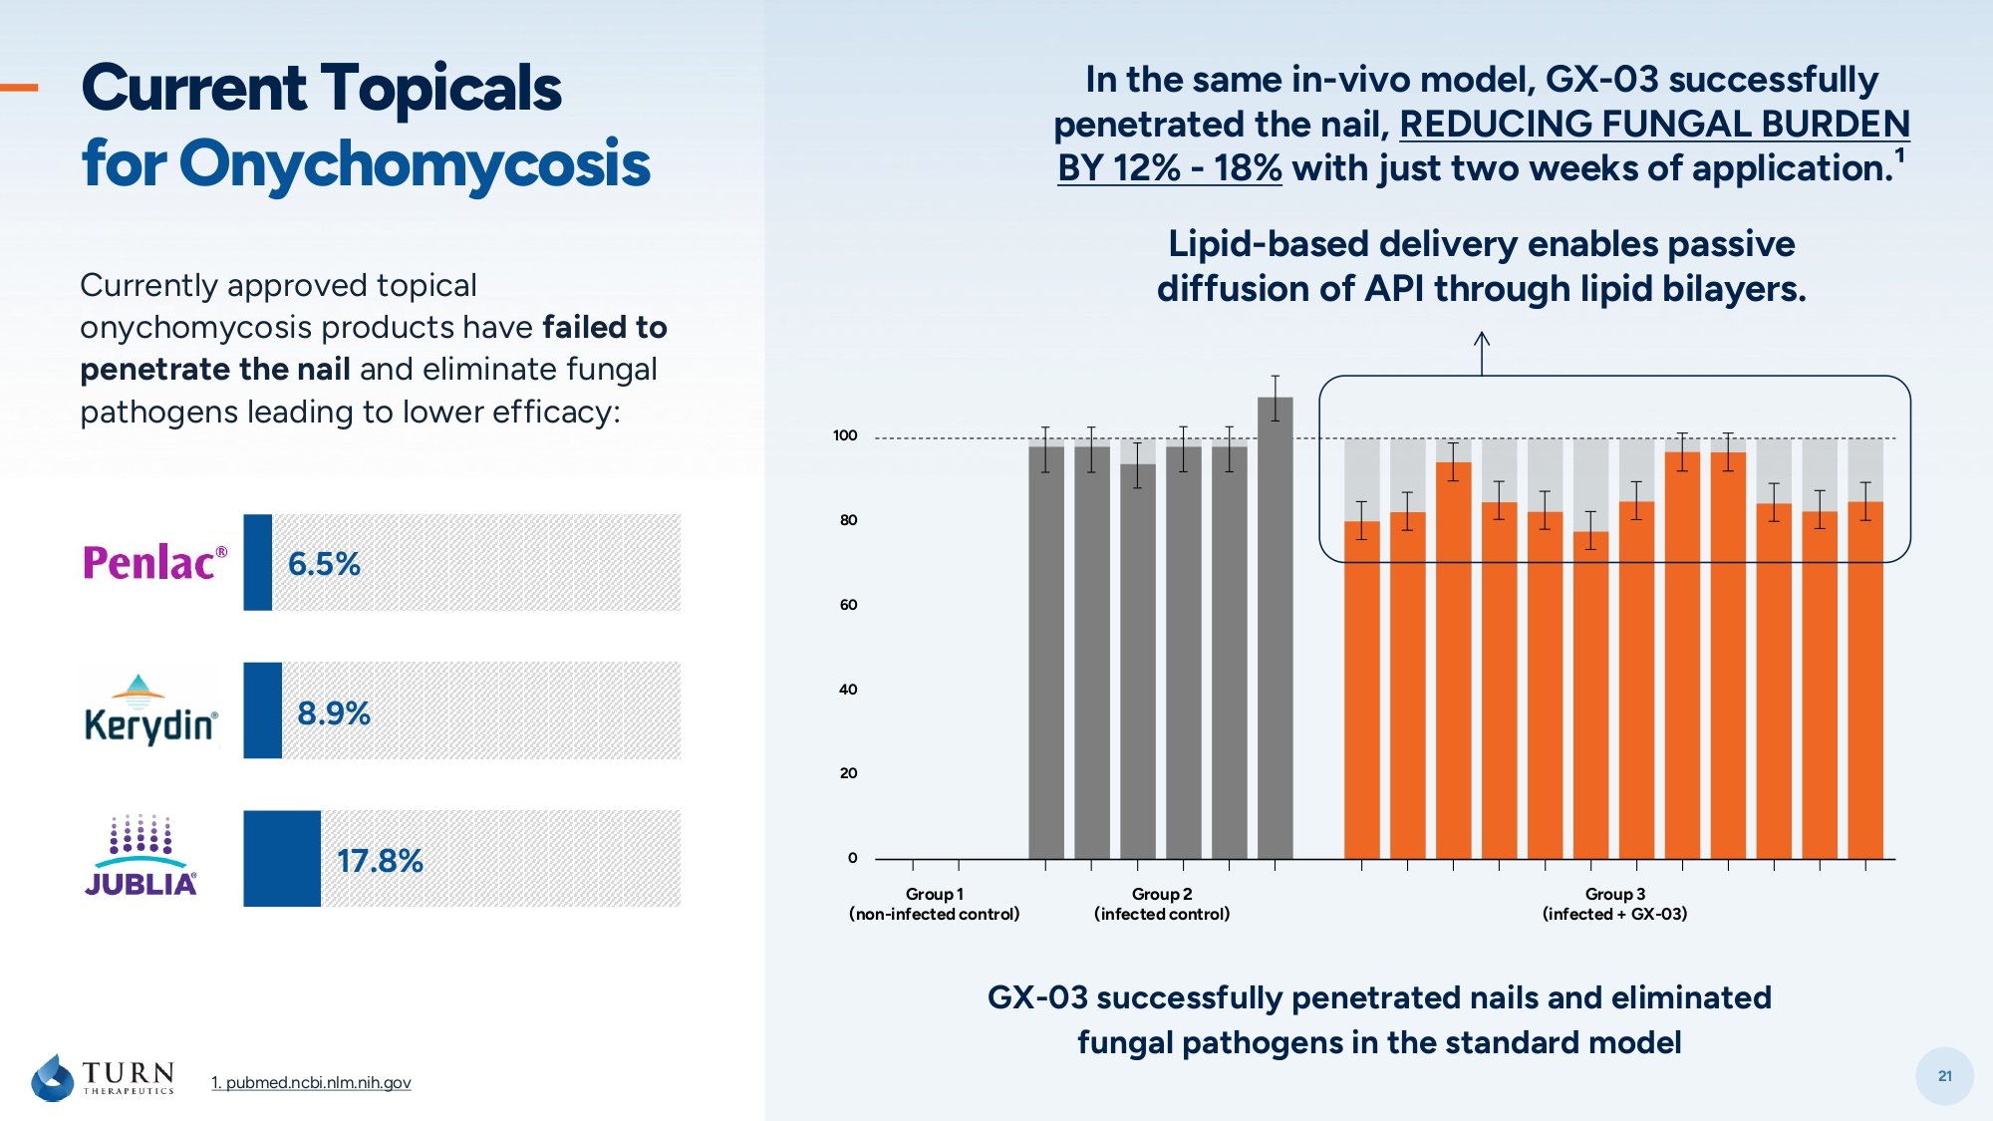
21 1. pubmed.ncbi.nlm.nih.gov GX - 03 successfully penetrated nails and eliminated fungal pathogens in the standard model In the same in - vivo model, GX - 03 successfully penetrated the nail, REDUCING FUNGAL BURDEN BY 12 % - 18% with just two weeks of application. ¹ Lipid - based delivery enables passive diffusion of API through lipid bilayers. Currently approved topical onychomycosis products have failed to penetrate the nail and eliminate fungal pathogens leading to lower efficacy: 8.9% 6.5% 17.8% Current Topicals for Onychomycosis 100 80 60 40 20 0 Group 3 (infected + GX - 03) Group 2 (infected control) Group 1 (non - infected control)

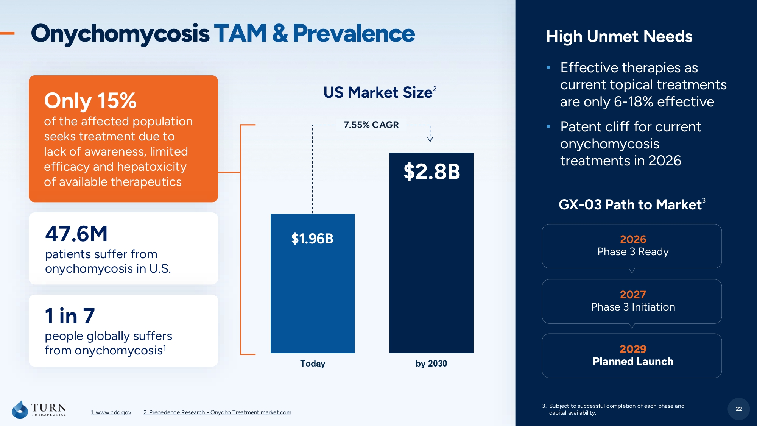
22 2026 Phase 3 Ready 2029 Planned Launch GX - 03 Path to Market 3 High Unmet Needs • Effective therapies as current topical treatments are only 6 - 18% effective • Patent cliff for current onychomycosis treatments in 2026 Onychomycosis TAM & Prevalence 3. Subject to successful completion of each phase and capital availability. Today by 2030 $1.96B $2.8B 7.55% CAGR US Market Size 2 2027 Phase 3 Initiation 22 47.6M patients suffer from onychomycosis in U.S. 1 in 7 people globally suffers from onychomycosis 1 Only 15% of the affected population seeks treatment due to lack of awareness, limited efficacy and hepatoxicity of available therapeutics 1. www.cdc.gov 2. Precedence Research - Onycho Treatment market .com


23 Our Science

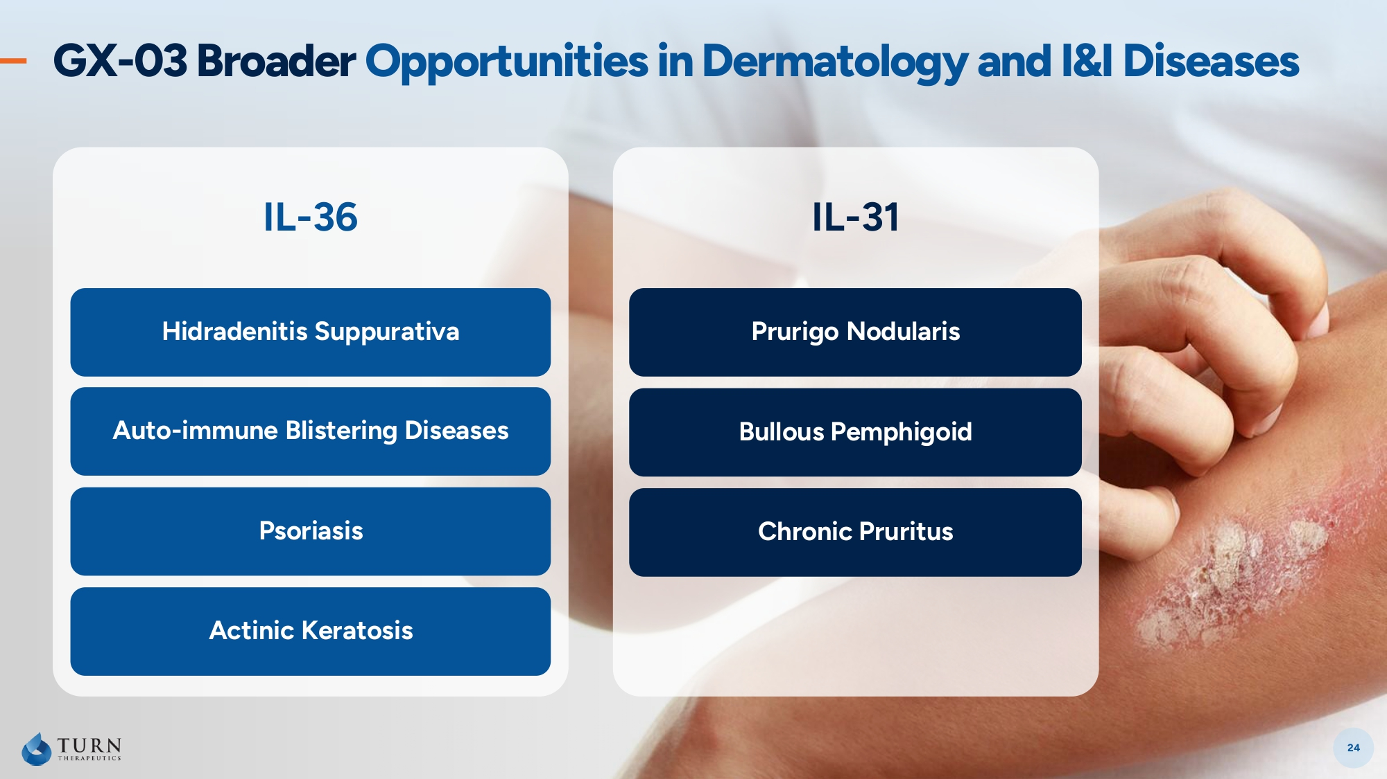
IL - 36 Auto - immune Blistering Diseases Psoriasis Actinic Keratosis Hidradenitis Suppurativa IL - 31 Prurigo Nodularis Bullous Pemphigoid Chronic Pruritus GX - 03 Broader Opportunities in Dermatology and I&I Diseases 24


25 Corporate & Financial Highlights

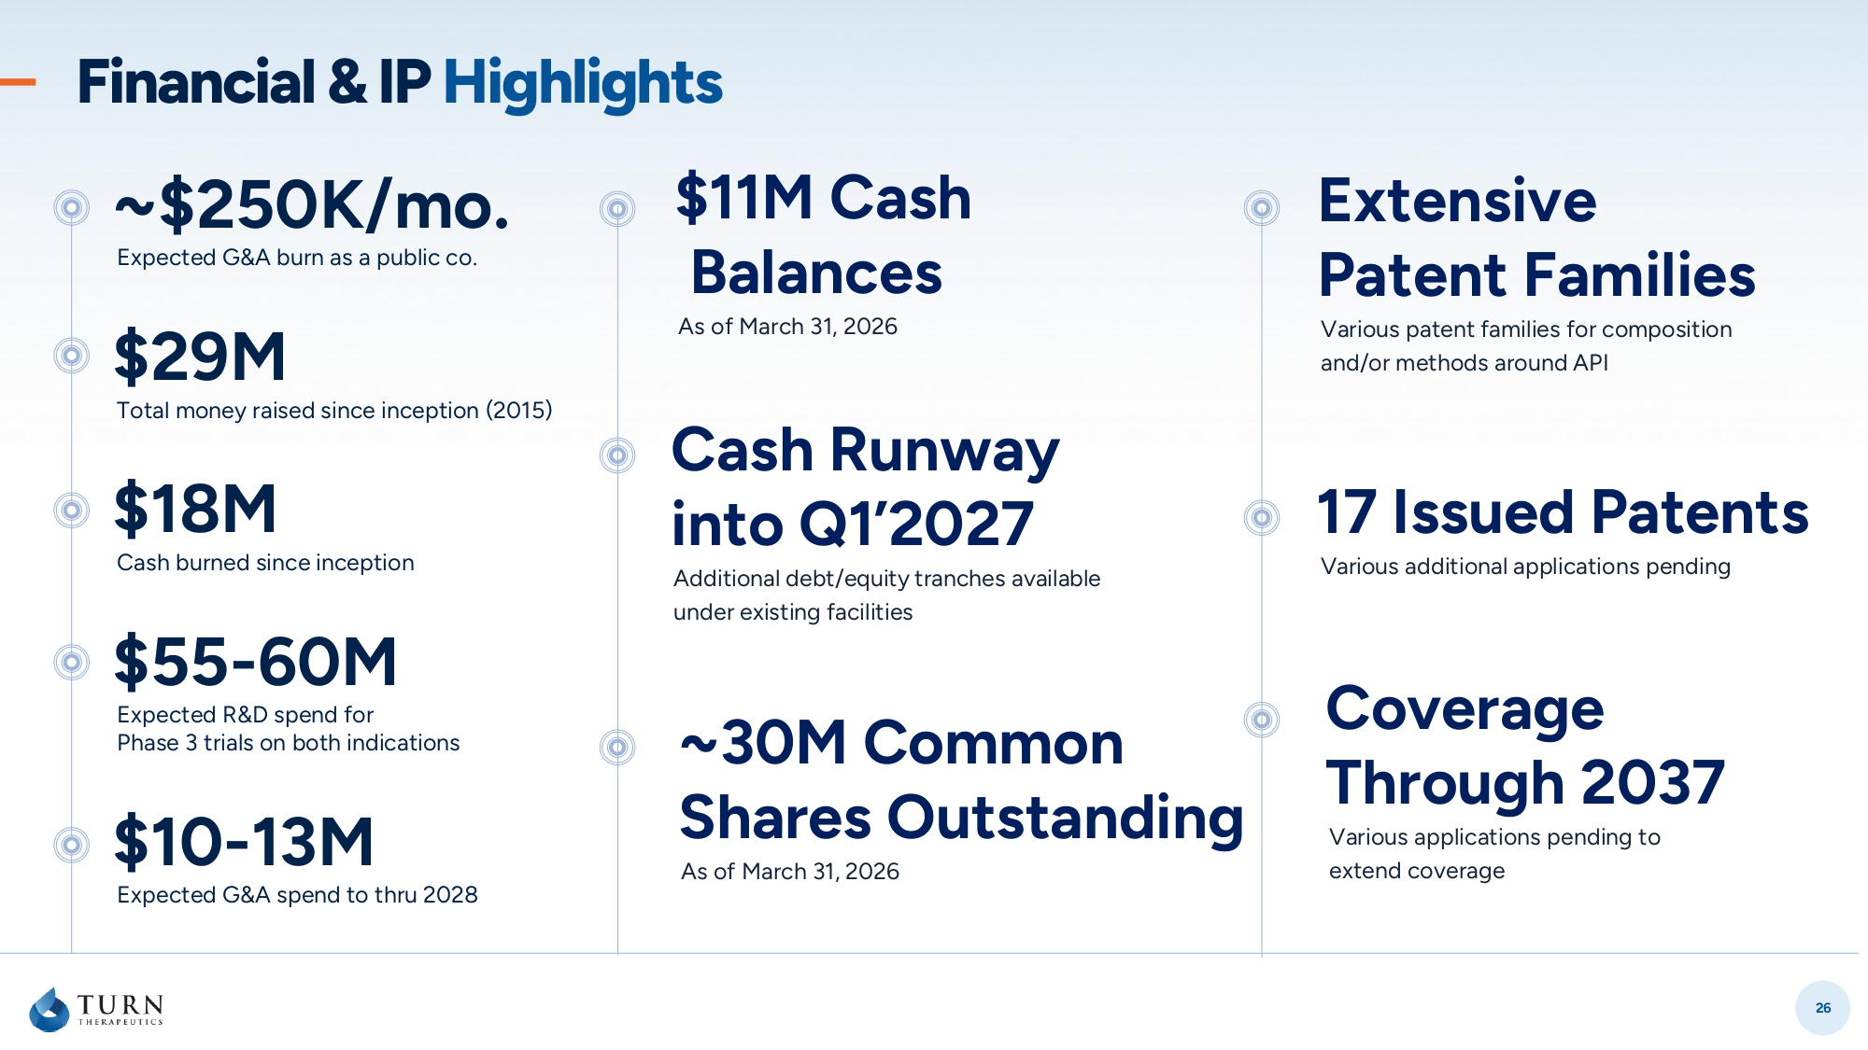
26 Financial & IP Highlights $18M Cash burned since inception $55 - 60M Expected R&D spend for Phase 3 trials on both indications ~$250K/mo. Expected G&A burn as a public co. $10 - 13M Expected G&A spend to thru 2028 $ 29M Total money raised since inception (2015) $11M Cash Balances As of March 31, 2026 ~30M Common Shares Outstanding As of March 31, 2026 Cash Runway into Q1’2027 Additional debt/equity tranches available under existing facilities Coverage Through 2037 Various applications pending to extend coverage 17 Issued Patents Various additional applications pending Extensive Patent Families Various patent families for composition and/or methods around API

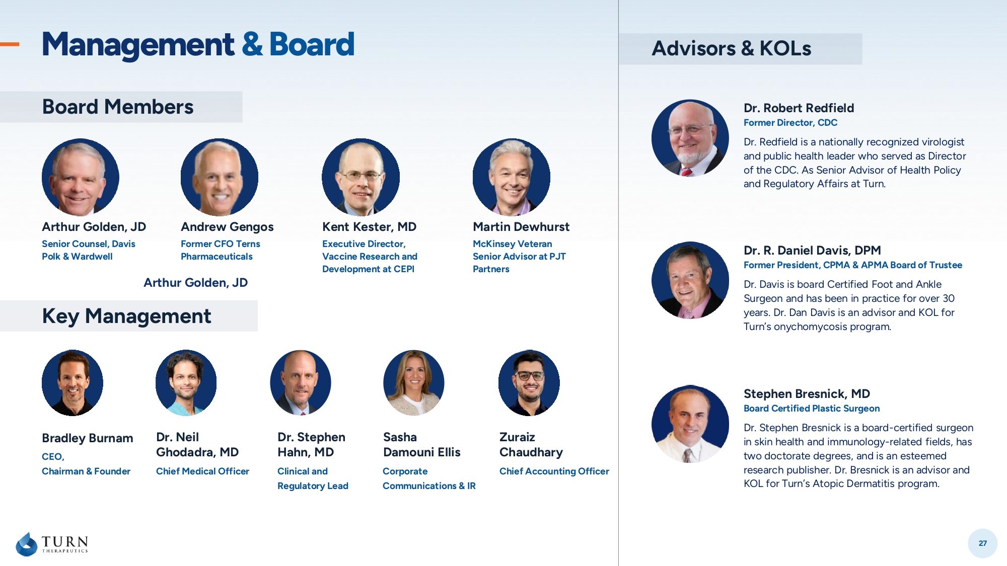
27 Board Members Advisors & KOLs Arthur Golden, JD Andrew Gengos Kent Kester, MD Martin Dewhurst Senior Counsel, Davis Polk & Wardwell Former CFO Terns Pharmaceuticals Executive Director, Vaccine Research and Development at CEPI McKinsey Veteran Senior Advisor at PJT Partners Bradley Burnam Dr. Stephen Hahn, MD Dr. Neil Ghodadra , MD Zuraiz Chaudhary CEO, Chairman & Founder Clinical and Regulatory Lead Chief Medical Officer Chief Accounting Officer Key Management Stephen Bresnick, MD Board Certified Plastic Surgeon Dr. Stephen Bresnick is a board - certified surgeon in skin health and immunology - related fields, has two doctorate degrees, and is an esteemed research publisher. Dr. Bresnick is an advisor and KOL for Turn’s Atopic Dermatitis program. Dr. R. Daniel Davis, DPM Former President, CPMA & APMA Board of Trustee Dr. Davis is board Certified Foot and Ankle Surgeon and has been in practice for over 30 years. Dr. Dan Davis is an advisor and KOL for Turn’s onychomycosis program. Dr. Robert Redfield Former Director, CDC Dr. Redfield is a nationally recognized virologist and public health leader who served as Director of the CDC. As Senior Advisor of Health Policy and Regulatory Affairs at Turn. Management & Board Sasha Damouni Ellis Corporate Communications & IR Arthur Golden, JD

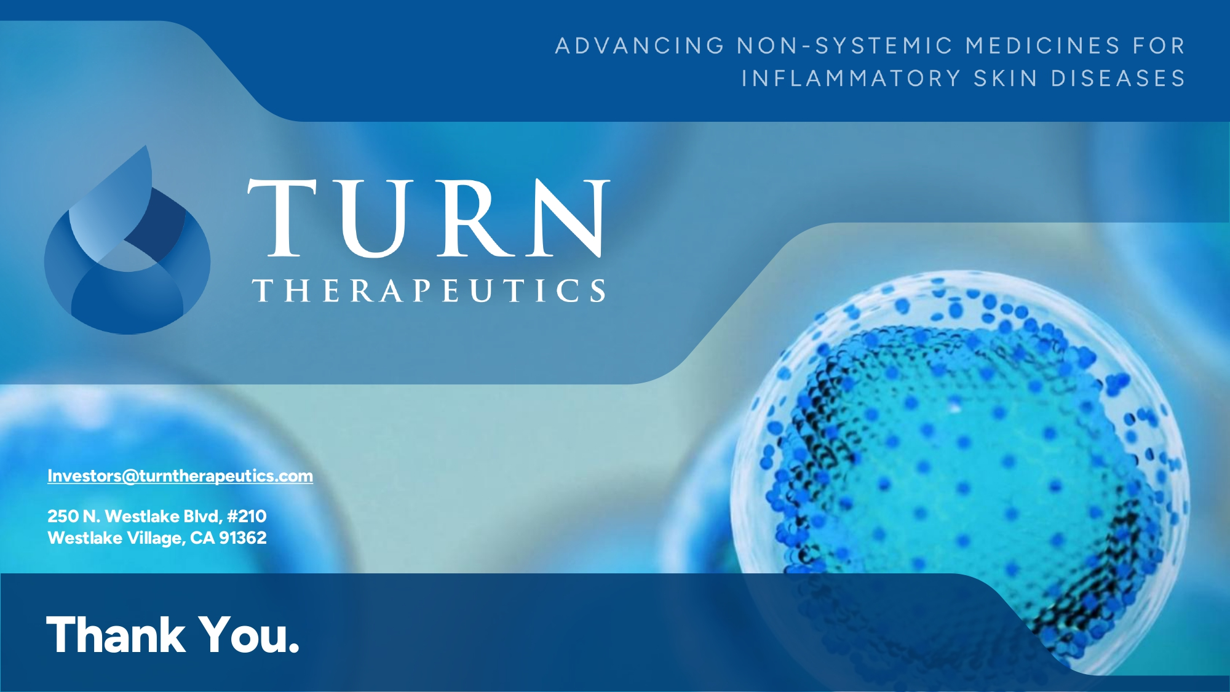
Investors@turntherapeutics.com 250 N. Westlake Blvd, #210 Westlake Village, CA 91362 Thank You.

